ELEC-2110

Electric Circuit Analysis

FROM: Jacob Howard

TO: Markus Kreitzer

DATE: January 22, 2020

LAB SECTION: 002

Electrical Measurements: Breadboarding, NI ELVIS,

Multimeter, Lab Reporting

# Introduction

The Objective of this lab was to learn the basic features of Ni Elvis Board and its software. The Elvis board is a bread board with convenient software tools that go long with it. This tool is a great way to learn circuit education in a safe environment.

# Exercise A

In exercise A, we were asked to use the Multimeter to find the actual resistance of 3 resistors as the theoretical values of resistance could be slightly off. We were also asked to calculate the percentage difference of each resistor using a formula. The information is shown below in Table 1 and the formula is show in formula 1 [1].

|  |  |  |  |  |  |
| --- | --- | --- | --- | --- | --- |
| Resistor | Theoretical Resistance | Minimum Resistance | Maximum Resistance | Actual Resistance | Percent Difference |
| R1 | 2200 Ω | 2090 Ω | 2310 Ω | 2185 Ω | 0.682% |
| R2 | 1500 Ω | 1425 Ω | 1575 Ω | 1496.8 Ω | 0.213% |
| R3 | 470 Ω | 446.5 Ω | 493.5 Ω | 463.57 Ω | 1.368% |

*Table 1*

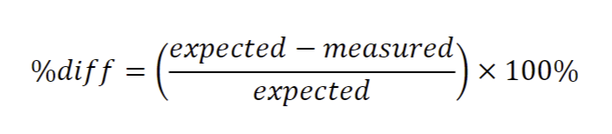

*Formula 1*

We were asked to use the resistors to construct a circuit on the Elvis board based on the circuit given to use in figure 1. Figure 1 is shown below [1].

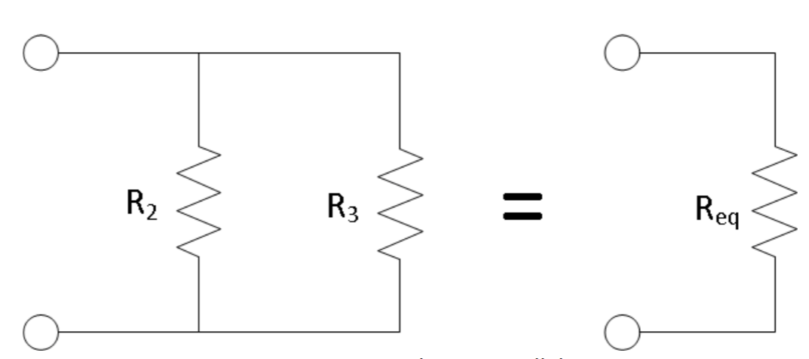

*Figure 1*

|  |  |  |
| --- | --- | --- |
| Resistor | Measured Resistance | Calculated Resistance |
| Req | 354.43 Ω | 357.87 Ω |
| Rtot | 2538.4 Ω | 2557.87 Ω |

Using the circuit made on the elvis board from figure 1, we were asked to measure the resistance of the parallel combination (Req). Using the measured values recorded in Table 1, we were able to calculate the theoretical equivalent resistance for the parallel combination of R2 and R3 (Req). We were also asked to add R1 in series with the other two resistors as in shown in Figure 2 and measure the new total resistance (Rtot) [1]. The results are listed below in table 2 and Figure 2 is shown below.

*Table 2*

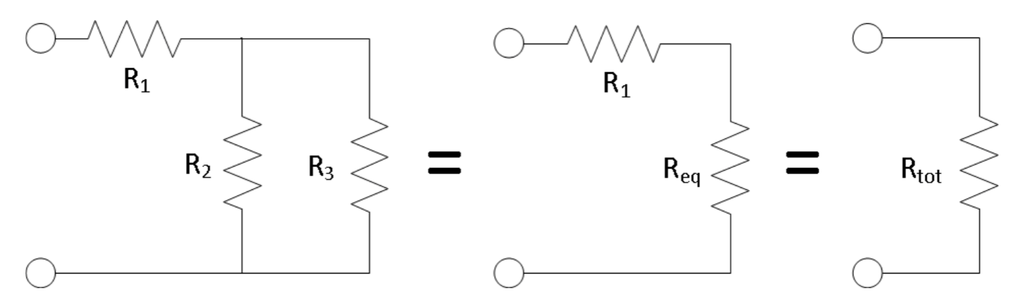

*Figure 2*

# Exercise B

In exercise B, we were asked to turn on the ELVIS board and use a multimeter, connect the voltage probe to the 15 V power supply pin on the ELVIS board and connect the neutral probe on the multimeter to the ground pin on the ELVIS board. This is to measure the voltage output of the 15 V power supply. We were asked to measure V1 and Veq as defined in Figure 3 below. We were then asked to measure Va and Vb as defined in Figure 4 below [1].

The measured voltages are recorded on Table 3 (Note that the measured voltage from the source was 15.6 Volts).

|  |  |
| --- | --- |
| Voltage | Value |
| Unloaded Source | 15.648 V |
| Vs | 15.648 V |
| V1 | 13.454 V |
| Veq | 2.1849V |
| Va | -13.454 V |
| Vb | -2.1849 V |

*Table 3*

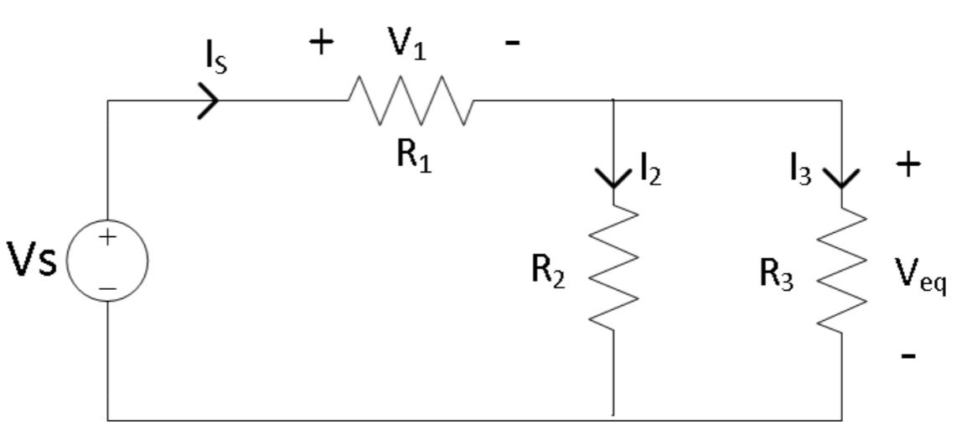

*Figure 3*

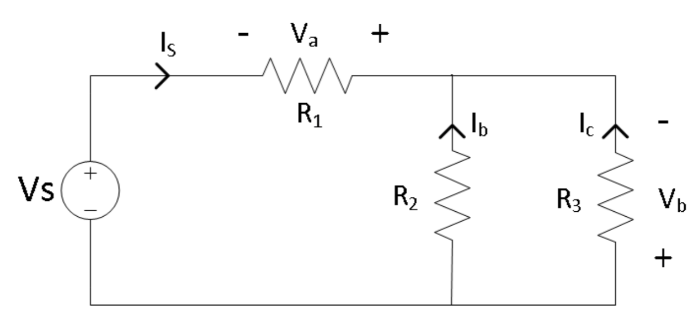

*Figure 4*

# Exercise C

In exercise C, we were asked to use the multimeter to measure Is, I2, and I3 as defined in Figure 3 above. Then we were to measure Ib and Ic as defined in Figure 4 above. To measure the current, we must place the leads in series [1]. Note that Ib = -I2 and Ic = -I3. Depending which way the current is flowing, the signs will change [1]. Data is shown in Table 4.

|  |  |
| --- | --- |
| Is | 6.11 mA |
| I2 | 1.36 mA |
| I3 | 4.64 mA |
| Ib | -1.36 mA |
| Ic | -4.64 mA |

*Table 4*

# Exercise D

In exercise four, we were asked to use the measured values for Vs, R1, and Req that were previously recorded, calculate V1 and Veq as defined in Figure 3 above with the voltage division equation. We are asked if these results resemble our previously measured values for V1 and Veq, which they do. Using Equation 2 below I was able to verify [1]. Data is in Table 5 below

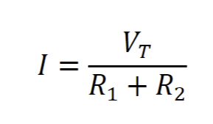

*Equation 2*

|  |  |
| --- | --- |
| **I** | 6.16 mA |
| R1 | 2185 Ω |
| Req (R2) | 354.43 Ω |
| VT | 15.648 V |

*Table 6*

Using Equasion 3, we are also able to find V1, Veq, I2, and I3. Equation 3 is below [1].

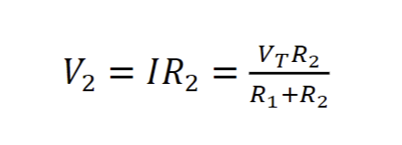

*Equation 3*

|  |  |
| --- | --- |
| V1 | 13.4596 V |
| Veq | 2.1833 V |
| I2 | 1.075 mA |
| I3 | 0.886 mA |

*Table 7*

***Note that (V1 = I*R1), ( Veq = I * Req), (I2 = Is(R3/(R2+R3))), (I3 = I2(R2/(R2+R3)))***

# Conclusion

This lab was used as an introduction on how to use the Elvis Board, some Elvis Board software, and Bread Board Circuitry. The lab guided us on how to construct a circuit on a Bread Board and on how to use the multimeter to measure resistance, voltage, and current. I did run into some problems on how to measure the current using the physical and digital multimeter, but my TA and peers helped me with explain how to measure the current correctly. Overall, this lab was a good introduction to Bread Board Circuitry.

# Bibliography

1. Brandon Eidson Elizabeth Devore Joel Killngsworth. “EXPERIMENT 2 Electrical Measurements”. In: (May 2016). url: https://auburn.instructure.com/courses/ 1196356/files/folder/Labs/Lab%20Manuals?preview=150563945